Queen’s Hall Arts Centre Venue Pack
Last updated September 2023
Table of Contents
Welcome 2
Key information 2
Our address: 2
Key contacts 2
Getting here 3
Parking 3
By bus 3
By train 3
Cycling 3
Local Taxis numbers 3
When you arrive 4
Staffing 4
Backstage 4
Dressing rooms 4
Wi-fi 4
Smoking 4
Loading 5
Main theatre: 5
Studio theatre: 7
Gallery space: 8
Where to eat / drink 10
Quick eats 10
Cafes: 10
Sit down meals: 10
Pubs 11
Digs list 12
Bed & Breakfast/Guest Houses 12
Hotels / Inns 12
Apartments 13

Welcome
We look forward to working with you in the lead up to your show. In this Venue Pack we aim to cover everything you need, but please don’t hesitate to get in touch if you have any questions.
Technical information is not included in this pack and can be found on the website under ‘Visiting Companies’.

Key information

Our address:
Queen's Hall Arts Centre,
Beaumont Street,
Hexham,
Northumberland.
NE46 3LS

What three words:
Box Office: 01434 652477 / boxoffice@queenshall.co.uk (10am – 4pm Monday – Saturday). Closed for one hour for lunch 12pm – 1pm.

Key contacts
Artistic Director: Katy Taylor – katy.taylor@queenshall.co.uk
Lead Technician: Scoon Ferguson – scoon.ferguson@queenshall.co.uk
Technical department - technical@queenshall.co.uk
Audience and Sales Manager: Helen Mills - helen.mills@queenshall.co.uk
Finance Manager: Lisa Berg: lisa.berg@queenshall.co.uk
Marketing Lead: Kelly France - kelly.france.123@outlook.com
Box Office Manager: Lucy Dunlop – lucy.dunlop@queenshall.co.uk

Getting here
We are located in the heart of Hexham, opposite Hexham Abbey on Beaumont Street.

What Three Words : ///banks.peachy.spreading

Parking
There is a limited number of parking spaces at the rear of the theatre for staff, artists and performers. If you require one of these spaces, please let our Box Office know and pick up a guest parking badge to display in your windscreen. However, due to the limited number of spaces, it may not be possible that a space can be provided.

There is also parking outside the Queen’s Hall including a limited number of disabled bays. These spaces are limited to two hours during the hours of 9am and 5pm and a parking disc is required (available to buy for £1 from our Box Office).

Longer Stay parking can be found at the Wentworth Car Park, Travelodge Car Park and Maiden’s Walk (M&S) Car Park.

The Wentworth Car Park is a five-minute walk away and is free but requires a parking disc. Bays are limited to four hours and there are some Longer Stay bays (often busy).

The Travelodge Car Park is a nine-minute walk away and is free and no disc is required. Parking in these bays is limited to 76 hours.

Please note there is a steep hill to walk up from both of these car parks to the venue.

Maiden’s Walk (M&S) carpark is seven-minute walk away. It is a private car park and charges apply.

By bus
We are a seven-minute level walk from Hexham Bus Station.

By train
We are a nine-minute walk from Hexham Train Station. Trains stop at stations East of Hexham along the Tyne Valley to Newcastle and beyond. They stop at stations West of Hexham to Carlisle. There is a steep hill to walk up from the train station to Queen’s Hall.

Cycling
There are cycle racks for locking up bikes on Beaumont Street which are managed by Northumberland County Council.

Local Taxis numbers
Eco cabs: 01434 600600
Advanced Taxis: 01434 606565
24 hour Slaley and Hexham Taxis: 01434 606464

When you arrive

Staffing
Staffing and support from the QHA team regarding your arrival and/or get in / performance and get out should be arranged in advance with our Lead Technician.

Backstage
Our backstage area can be accessed via the stage door at the rear of the building which has a password protected key pad.
It can also be accessed from inside the public entrance via the Studio corridor which also has a password protected key pad.
Please arrange in advance with the Lead Technician if you need the codes for our backstage area.
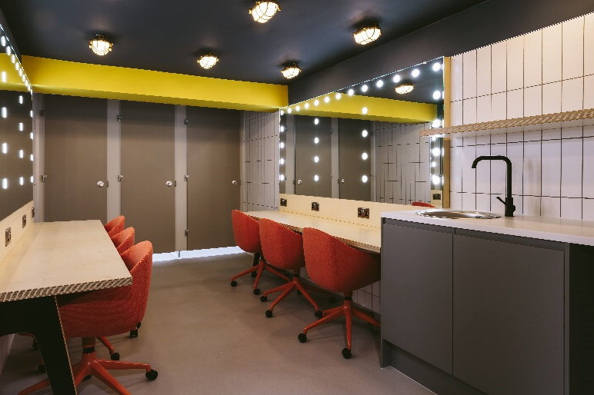
Please be aware that Queen’s Hall Arts can sometimes be very busy and the backstage area might also be used by other performers.

Dressing rooms
We have two six person dressing rooms. Both include toilets and showers and are also kitted out with a kettle, fridge, sink and microwave.
A washing machine is located near the dressing rooms and is available if needed.

Wi-fi
Free guest wi-fi is available throughout the building.
Name: Queen’s Hall Guest
Password: Qhawifi!

Smoking
Queen’s Hall is a smoke free building. This includes vapes. There is a designated smoking area at the rear of the building. There is also a public park opposite the front of the building.

Loading

Main theatre:
The loading bay for access to the main theatre is at the rear of the theatre. There is good access for large vehicles and trucks but please notify us in advance if you need space for an oversized vehicle.
There is also ground level loading for the main theatre between Queen’s Hall and the Hexham Trinity Methodist Church.
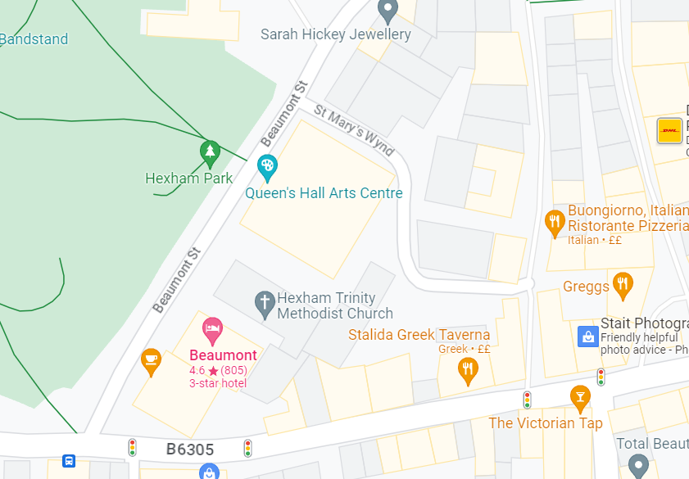
Stage door - level
Stage door and loading bay (raised)
Stage loading:
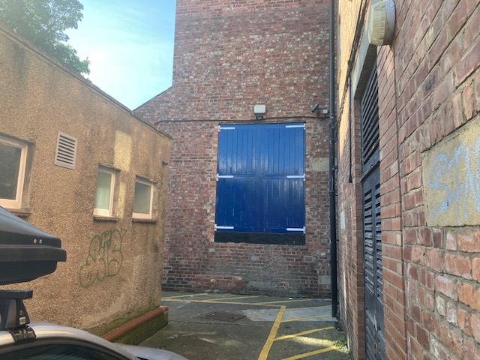
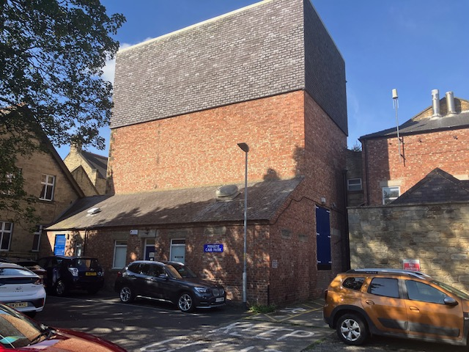
Stage loading
Stage door

Studio theatre:
The loading bay for access to the studio theatre is to the side of the theatre and is down a flight of stairs to the basement.
There is good access for large vehicles and trucks but please notify us in advance if you need space for an oversized vehicle.
Studio loading / fire exit (down stairs)
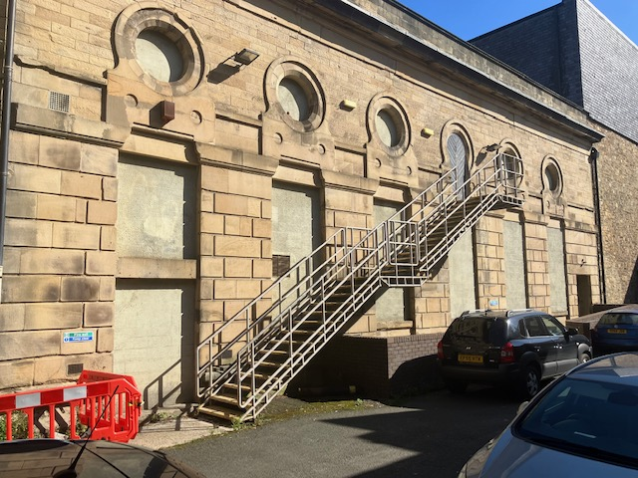
Loading down stairs
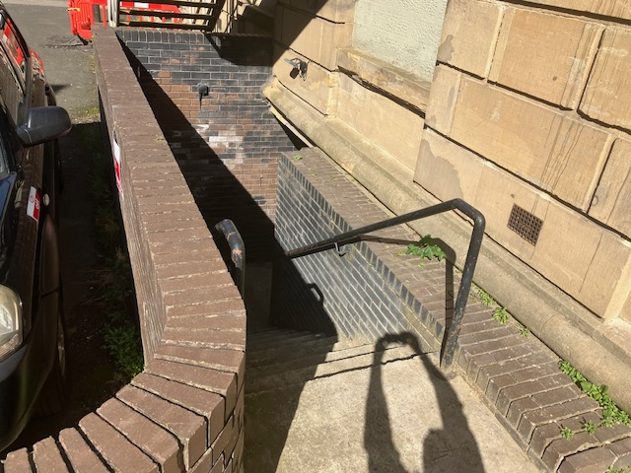

Gallery space:
Loading / unloading for the gallery spaces is via the fire escape double doors into Gallery 1 from Beaumont Street.
Via fire exit double doors
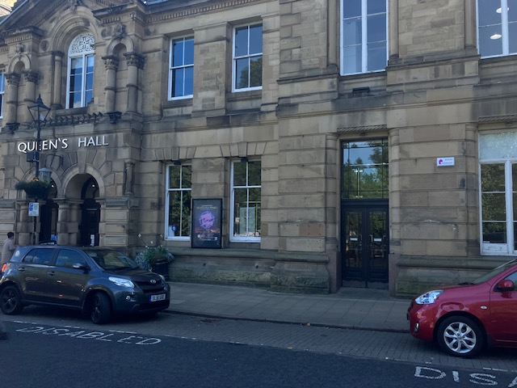
Gallery 1 & 2 loading

Where to eat / drink
Please arrange any riders with our Lead Technician in advance of your performance.

We have an onsite café in the building which is open Tuesday – Saturday 10am – 4pm.

Listed below are some of our recommended places to eat and drink locally. There are plenty more eateries and pubs in and around Hexham including supermarkets: Tesco, Waitrose Lidl and Aldi.

Quick eats
- Little Mexico:
  - Sit in and takeaway authentic Mexican food.
  - 4a Market Street
  - 01434 622329
  - Tues – Sat: 11am – 9pm

- Greggs:
  - 41 Fore Street
  - Mon – Sat: 7am – 6pm, Sun: 8am – 5pm

Cafes:
- Market Place café
  - Great coffee
  - Tues – Sat: 8am – 4pm
  - 14 Market Place

- Small World Café
  - Mon – Sat: 9am – 4pm
  - 27-28 Market Place

Sit down meals:
- Heart of Northumberland (gastro pub)
  - 5 Market Street
  - 014340608013
  - Mon: 12pm – 10pm
  - Tues: 4pm – 10pm
  - Wed – Sat: 12pm – 11pm
  - Sun: 12pm – 9pm

- Beaumont Hotel (Modern British)
  - Beaumont Street
  - 01434 602331

- Bouchon Bistrot (French)
  - Gilesgate
  - 01434 609943
  - Tue - Sat: 12pm – 1.45pm / 6pm – 9.15pm

- Buongiorno (Italian pizza / pasta)
  - 12 St Mary’s Chare
  - 01434 601700
  - Mon – Thurs: 12pm – 9pm. Fri – Sat: 12pm – 10pm

- Vercelli (Italian pizza / pasta)
  - 36 – 38 Priestpopple
  - 01434 603350
  - Tues – Thurs: 12pm – 2pm / 5pm – 8pm
  - Fri – Sat: 12pm – 2pm / 5pm – 8.30pm

- Cilantro (Indian tapas)
  - 19 Market Place
  - 01434 601234
  - Tues – Sat: 5pm – 10pm

- Zyka (Modern Indian)
  - 44 Priestpopple
  - Sun – Thurs: 5.30pm – 10.30
  - Fri – Sat: 5.30 – 11.30

Pubs
- Heart of Northumberland (also serves food)
  - 5 Market Street
  - 014340608013
  - Mon: 12pm – 10pm
  - Tues: 4pm – 10pm
  - Wed – Sat: 12pm – 11pm
  - Sun: 12pm – 9pm

- The Tannery (also serves food)
  - Gilesgate
  - 01434 605537
  - Sun – Thurs: 12pm – 11pm.
  - Fri – Sat: 12pm – 12am

- Victorian Tap (also serves bar snacks)
  - Battle Hill
  - 01434 622046
  - Mon – Thurs: 3pm – 11pm
  - Fri – Sat: 12pm – 12am
  - Sun: 12pm – 10pm

Digs list
Please note this list is not exhaustive and Queen's Hall assumes no responsibility or liability for your stay at any of the listed below accommodations.

Bed & Breakfast/Guest Houses
- Alison Cunningham – static caravan in garden central Hexham. 15 min walk from QHall: Spacious centrally heated caravan near town centre - Guest houses for Rent in Northumberland, England, United Kingdom - Airbnb
- High Reins, (1 mile from Queen’s Hall), Leazes Lane, Hexham, NE46. Single room-ensuite rate £56.00 Double & twin £86.00 Includes breakfast. Tel: 01434 603590 / 07720052906 Peter & Jan Walton
- 3 single rooms, 2 doubles and one twin room, all en suite. www.highreins Also offer self-catering accommodation for up to 4 people in Hexham town centre.
- Henshaw Barn, (7 miles out of Hexham.) Henshaw, NE47 7EN, Tel: 01434 344453, www.henshawbarn.co.uk Pauline Ellis. Two double, ensuite. Large double can be converted to twin. Breakfast included. £85 small double, £100 large double. Closed end October to mid March.
- Anick Grange Farm B&B NE46 4LP- (2 miles from Queen’s Hall), Open from Easter – September. Two rooms, both ensuite , 1 double , 1 twin - £85.00. Tel 07712 418945
- Loughbrow House B&B, NE46 1RS – (1 mile from Queen’s Hall.) 1 double ensuite, 1 twin ensuite, 2 singles to share bathroom. Cost for 1 night £120 or £55. Cost for 2 nights £120 per night or £50 per night. Breakfast included. Tel 01434 603351
- The Gin Gan, (4 miles from Hexham), East Fourstones, Hexham NE47 5DX – 2 king size rooms 1 en-suite 1 private bathroom – full English breakfast £100. Open April to October. Tel: 01434 674182
- Corbridge Guest House, (5 miles from Hexham). 1 Leazes Terrace, Corbridge, NE45 5HS. 2 rooms, 1 Kingsize and 1 twin. Will advertise on airbnb and bookings made through airbnb only. £150 per night/£195 in peak times.

Hotels / Inns
- Travel Lodge - Travelodge Hexham (15 min walk into Hexham): https://www.travelodge.co.uk/hotels/696/Hexham-hotel Prices from £45
- Beaumont Hotel, Beaumont Street, Hexham (a few doors up from Queen’s Hall). Tel: 01434 602331 Single: £88 double: £110. All ensuite, includes breakfast.
- The County Hotel, (5 min walk to Queen’s Hall). Priestpopple Hexham. Tel: 01434 60844. 7 ensuite rooms - 7 ensuite - 2 king deluxe, 2 king standard, 2 double, 1 family room £109 - £149 includes breakfast.
- The Boatside Inn, Warden Hexham NE46 4SQ – 3 miles from Hexham. B & B annexes x 3. Each 1 sleeps up to 2 plus Z bed if needed. £95 per night, includes breakfast. Tel: 01434 602233
- The Station Inn, (15 min walk to Queen’s Hall). Station Road, Hexham, NE46 1EZ, Tel: 01434 603155 Above a pub, basic accommodation, all en-suite. 6 twin rooms £75 each. One quad room for 4, £100 4 single rooms £45.
- The Red Lion Inn Newbrough Hexham NE47 5AR , 5 miles from Hexham . 6 rooms, all en suite 3 twin/double, 1 double, 1 family room , 1 superior double. Includes breakfast. £70 single occupancy, £85/£90 double . Tel 01434 674226

Apartments
- 1 bedroom apartment on Eastgate brand new: https://www.airbnb.com/h/vinecottage-9-eastgate Ring Sally Anderson direct to cut out costs of airbnb – Sally Anderson 07802 289732
- The Side – double room, self contained apartment , discount for performers. £85 per night plus £20 service charge for booking 07961 590921 The Side@sidehexham.com www.sidehexham.com
- Hexham Hideaways , 1 self catering apartment in the centre of Hexham. Prices from £75 per night. Minimum 3 nights . Includes 1 double, 1 twin, both en-suite . www.sammyshideaways.com. Telephone – 07903038623/ 07743344822
- Dilston Mill Corbridge, NE45 5QZ Studio with kingsize bed, ensuite, own kitchenette & own front door £113 based on 2 people sharing . Also 1 twin , 1 double with breakfast room & shower room. Two people £113, 3 people £155, 3 people £200 per night. Tel: 01434 633493.
- Newbrough Bunkhouse (10 minute drive). Tel: 01434 674315. Bunkhouse Accomodation - Newbrough Bunk House
- Burnlaw Centre (25 min drive). www.burnlaw.org. Tel: 01434 345359.
- Also try Airbnb for various options.

